**Student Database Management System (PostgreSQL)**

Design and implement a student database management system using PostgreSQL that allows storing and retrieving student information efficiently.

1. **Database Setup**

Create a database named "student_database."

Create a table called " student_table " with the following columns: Student_id (integer), Stu_name (text), Department (text), email_id (text ),Phone_no (numeric), Address (text), Date_of_birth (date), Gender (text), Major (text), GPA (numeric), Grade (text) should be A,B,C Etc.

CREATE DATABASE student_database;

-- Create Table with constraints

CREATE TABLE student_table (

Student_id INTEGER PRIMARY KEY,

Stu_name TEXT NOT NULL,

Department TEXT NOT NULL,

email_id TEXT UNIQUE,

Phone_no NUMERIC(10),

Address TEXT,

Date_of_birth DATE,

Gender TEXT CHECK (Gender IN ('Male', 'Female', 'Other')),

Major TEXT NOT NULL,

GPA NUMERIC(3,2) CHECK (GPA >= 0.00 AND GPA <= 4.00),

Grade TEXT CHECK (Grade IN ('A', 'B', 'C', 'D', 'F'))

);

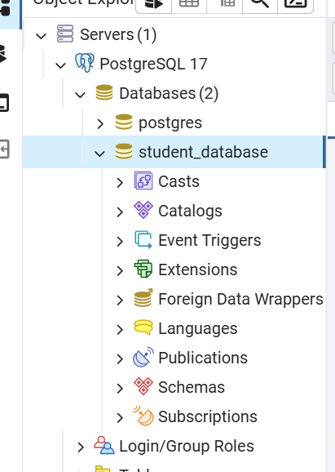

1. **Data Entry**

Insert 10 sample records into the "student_table" using INSERT command.

INSERT INTO student_table VALUES

(1001, 'Priya Sharma', 'Computer Science', 'priya.s@email.com', 9876543210, '123 Gandhi Road, Chennai', '2000-05-15', 'Female', 'Software Engineering', 3.85, 'A'),

(1002, 'Rahul Kumar', 'Electronics', 'rahul.k@email.com', 9876543211, '456 Anna Nagar, Chennai', '2001-07-22', 'Male', 'VLSI Design', 3.45, 'B'),

(1003, 'Anjali Patel', 'Mechanical', 'anjali.p@email.com', 9876543212, '789 T Nagar, Chennai', '2000-03-30', 'Female', 'Robotics', 3.92, 'A'),

(1004, 'Karthik Rajan', 'Computer Science', 'karthik.r@email.com', 9876543213, '234 Adyar, Chennai', '2001-11-12', 'Male', 'Data Science', 3.78, 'A'),

(1005, 'Meena Sundaram', 'Electronics', 'meena.s@email.com', 9876543214, '567 Mylapore, Chennai', '2000-09-25', 'Female', 'Communications', 3.25, 'B'),

(1006, 'Arun Kumar', 'Civil', 'arun.k@email.com', 9876543215, '890 Velachery, Chennai', '2001-04-18', 'Male', 'Structural Engineering', 2.95, 'C'),

(1007, 'Deepa Venkat', 'Computer Science', 'deepa.v@email.com', 9876543216, '345 KK Nagar, Chennai', '2000-08-09', 'Female', 'Cybersecurity', 3.88, 'A'),

(1008, 'Senthil Raja', 'Mechanical', 'senthil.r@email.com', 9876543217, '678 Porur, Chennai', '2001-01-30', 'Male', 'Automobile Engineering', 3.15, 'B'),

(1009, 'Lakshmi Priya', 'Electronics', 'lakshmi.p@email.com', 9876543218, '901 Tambaram, Chennai', '2000-12-05', 'Female', 'IoT Systems', 3.67, 'A'),

(1010, 'Vishnu Kumar', 'Civil', 'vishnu.k@email.com', 9876543219, '432 Chromepet, Chennai', '2001-06-28', 'Male', 'Environmental Engineering', 2.85, 'C');

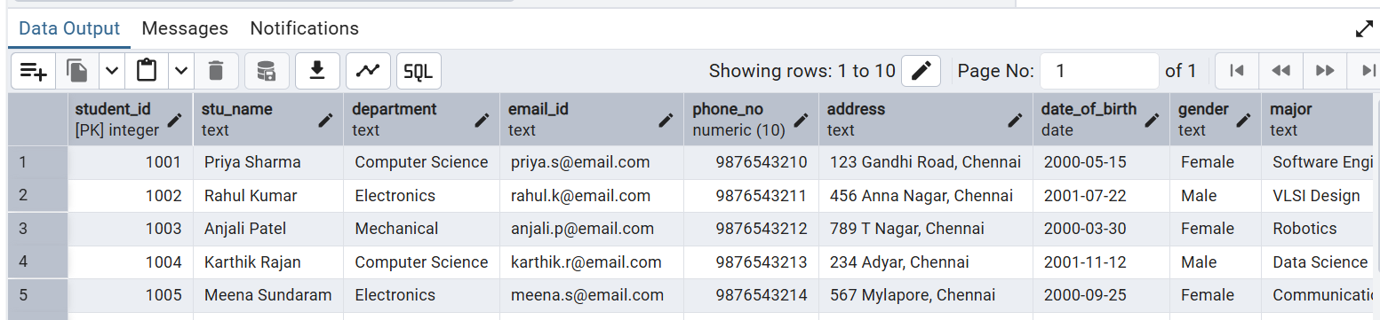

1. **Student Information Retrieval**

Develop a query to retrieve all students' information from the "student_table" and sort them in descending order by their grade.

select * from student_table order by grade desc;

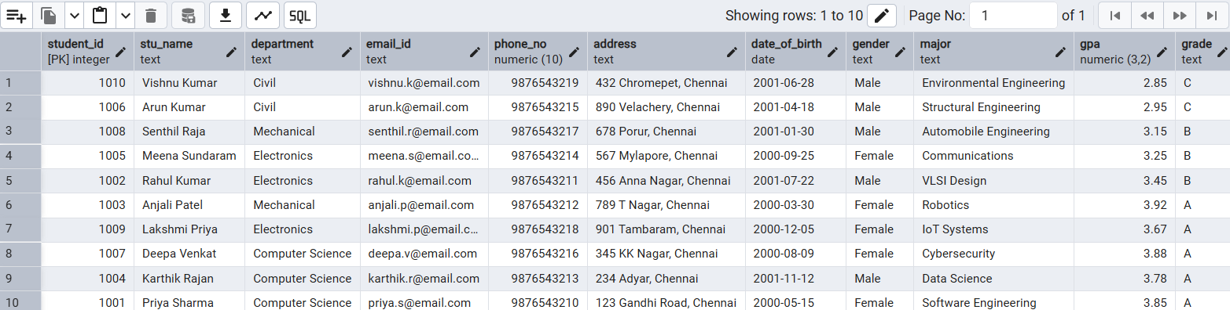

1. **Query for Male Students**

Implement a query to retrieve information about all male students from the "student_table."

select * from student_table where gender = 'Male';

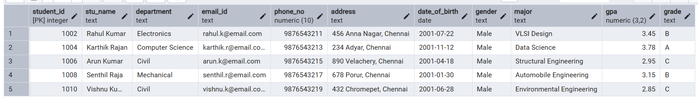

1. **Query for Students with GPA less than 5.0**

Create a query to fetch the details of students who have a GPA less than 5.0 from the "student_table."

select * from student_table where gpa < 5.0;

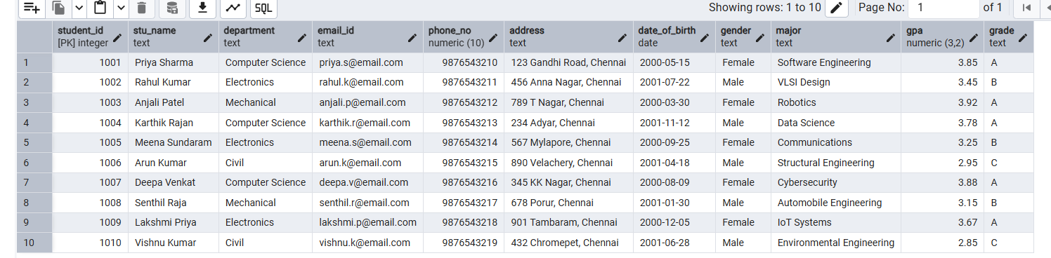

1. **Update Student Email and Grade**

Write an update statement to modify the email and grade of a student with a specific ID in the "student_table."



update student_table set email_id = 'priya@email.com' where student_id = 1001;



1. **Query for Students with Grade "B"**

Develop a query to retrieve the names and ages of all students who have a grade of "B" from the "student_table."

select * from student_table where grade = 'B';

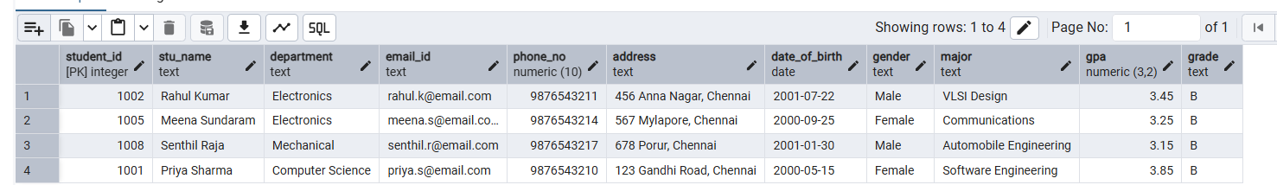

1. **Grouping and calculation**

Create a query to group the "student_table" by the "Department" and "Gender" columns and calculate the average GPA for each combination.

select department, round(avg(gpa), 3) as gpa_avg from student_table group by department, gender ;

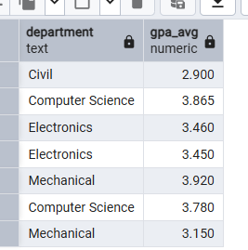

1. **Table Renaming**

Rename the "student_table" to "student_info" using the appropriate SQL statement.

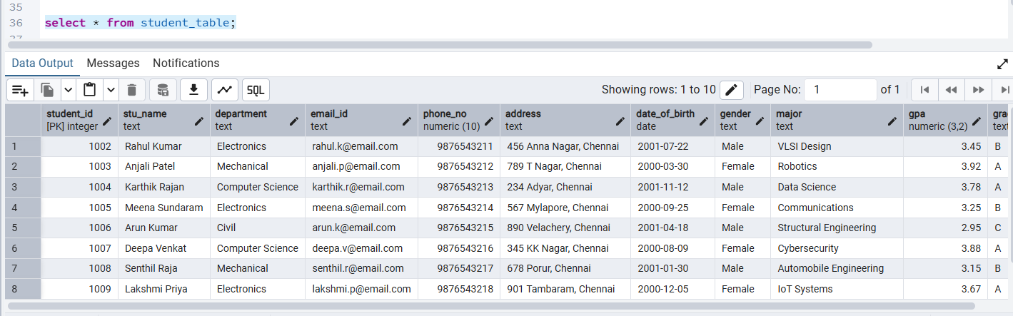

ALTER TABLE student_table RENAME TO student_info;

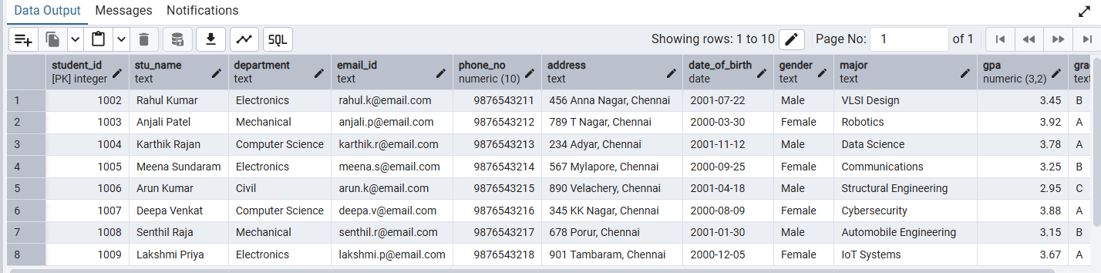

1. **Retrieve Student with Highest GPA.**

Write a query to retrieve the name of the student with the highest GPA from the "student_info" table.

select stu_name from student_info where gpa = (select max(gpa) from student_info);

